Gambar 1. (T.Code MM03)

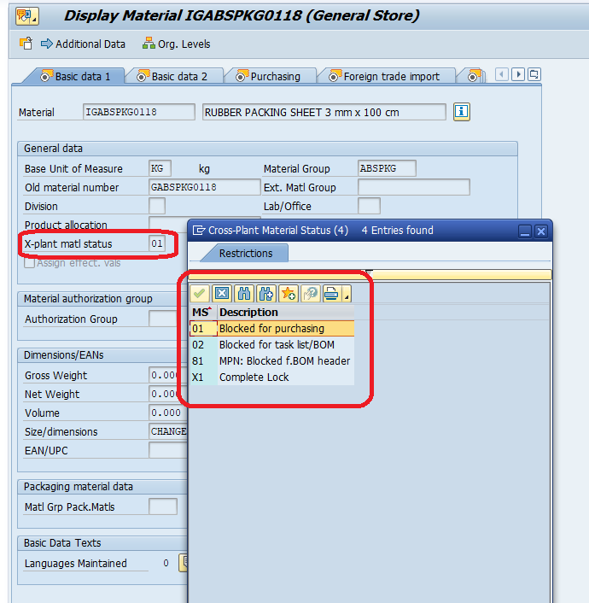

Tolong di report tersebut di tampilkan data seperti berikut;

|  |  |  |  |  |  |
| --- | --- | --- | --- | --- | --- |
| **ItemCode** | **Description** | **Last Change** | **CHANGE BY** | **X-plant matl status** | **Remark** |
| IGABSPKG0118 | RUBBER PACKING SHEET 3 mm x 100 cm | 30.08.2022 | NUR CAHYONO | 01 | Block For Purchasing |
| IGWLSSEQ0168 | DISPOSABLE FACE MASK 3-Play (Glas Free) | 06.04.2020 | IT SUPPORT |  |  |

Note : Jika material tersebut masih active maka, xplant matls status nya kosong

Sedangkan Pilihan Reportnya seperti berikut;

|  |  |  |  |  |
| --- | --- | --- | --- | --- |
|  |  |  |  |  |
| **ItemCode** |  | To |  |  |
|  |  |  |  |
| Plant |  | To |  |  |
|  |  |  |  |
| Material Type |  | To |  |  |
|  |  |  |  |
| |  | | --- | |  | | Active |  |  |  |
| |  | | --- | |  | | Block |  |  |  |
| |  | | --- | |  | | All |  |  |  |